Department of Computer Science and Engineering (Data Science)
CSDS-A | Batch A6 (CSE - Data Science, Section A)
ClauseGuard: Legal Contract Complexity and Predatory Clause Detector
(ClauseGuard)
S.No. | Student name | Roll / hall ticket no.
1 | CH.PRANATHI | 23K91A6744
2 | G.PRANAVI | 23K91A6762
3 | G.CHARAN JOSEPH | 23K91A6753
4 | G.BHAGWATH | 23K91A6760
Under the guidance of: [GUIDE NAME], [DESIGNATION]
METHODOLOGY, NOVELTY AND KEY CONTRIBUTIONS
This document describes how ClauseGuard works from end to end, why its algorithms were chosen, what is different from the base paper, and the contributions of the project. All figures are measured values from the project's own artefacts (docs/REPORT_FACTS.md).

1 Overall Methodology
ClauseGuard follows a review chain that a careful reader would follow by hand, and automates each link: the contract is read, split into clauses, each clause is given a type, each clause is tested against a short list of terms that Indian contract law treats as suspect, the clauses that are dangerous only in combination are found, the wording is scored for difficulty, and the findings are written back in plain language with a fairer alternative. The base paper [1] builds a retrieval-augmented consultation system and a contract-analysis module on Gemini 1.5 Flash for Saudi law, and checks contracts against a checklist of essential clauses with an LLM-assisted semantic test. ClauseGuard keeps the idea of a jurisdiction-aware, Gemini-based analysis, but changes the division of labour: the decision that a clause is predatory is taken by deterministic rules, and the language model is used for embeddings and for wording.
Three differences from the project abstract and from the base paper must be stated at the outset. First, the build uses Gemini for embeddings and text; the abstract names the Claude API. Second, vectors are stored as blobs in SQLite and compared with NumPy, and the clause graph is a NetworkX graph rebuilt for every request; the abstract names pgvector and Neo4j. Third, there is no retrieval over a legal corpus: the only retrieval step is the nearest-centroid match of a clause against 20 CUAD category centroids, and Gemini is given the rule's legal basis in the prompt rather than retrieved passages. The method is therefore a rule-and-embedding pipeline with an LLM writing layer, and it should be judged as that.
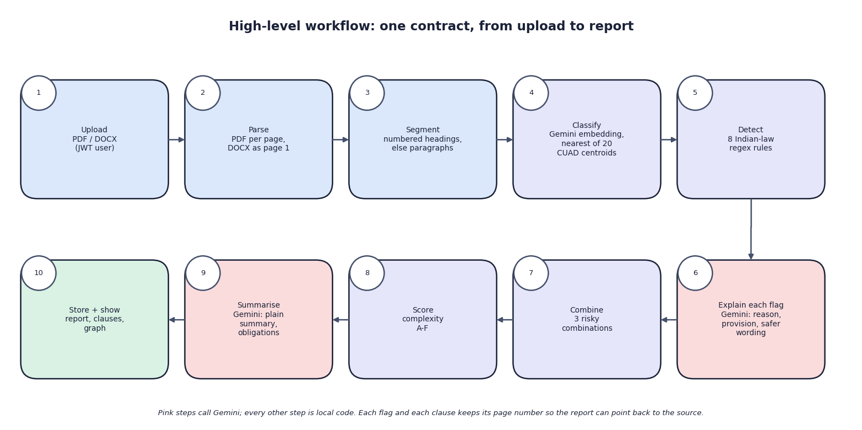
Fig. 1: High-level workflow of ClauseGuard, from upload to report
Table 1: Pipeline of ClauseGuard
Step | Method | Output
1 Parse | PyMuPDF for PDF (one page per page); python-docx for DOCX (whole file is page 1) | Pages of raw text
2 Segment | Split each page at numbered headings (1., 2.1, Section 3); if a page has fewer than two headings, merge blank-line paragraphs up to about 400 characters | Clauses with index and page number
3 Classify | Gemini embedding (3,072 values); cosine similarity to 20 CUAD category centroids; Gemini tie-break when two categories are close | Clause type, confidence, method
4 Detect | Eight case-insensitive regular-expression rules, each tagged with severity and an Indian statute | Flags per clause
5 Explain | One Gemini call per flag: reason, quoted provision, safer wording | Plain-language flag record
6 Combine | Three combinations of rule ids matched anywhere in the contract; NetworkX graph | Risky combinations and graph edges
7 Score | Flesch reading ease, legalese density, cross-references, sentence length; weighted 0-100 score; grade A-F | Complexity grade and four component values
8 Summarise | One Gemini call over the first 40 clause excerpts and the flag list | Plain summary and key obligations
9 Store and show | One SQLite transaction; report, clause and graph endpoints | Report, clause detail, graph

2 Dataset
The project has no labelled corpus of Indian contracts, and none is publicly available in a form that could be used here. The only labelled clause data is the Contract Understanding Atticus Dataset (CUAD) [8], a corpus of United States commercial contracts filed with the Securities and Exchange Commission and annotated by lawyers with 41 clause categories. The predatory-clause rules are therefore written by hand, and the classification step is trained and tested on CUAD. The datasets used are summarised below.
Table 2: Datasets used
Dataset | Role | Source and licence | Size
CUAD v1 [8] | Source of all classification data; corpus-scale run | The Atticus Project, data/cuad/CUADv1.json (about 40 MB), CC BY 4.0 | 510 contracts, 41 categories; 20 substantive categories used
Training spans | Build 20 category centroids | Derived from CUAD by scripts/build_cuad_samples.py, seed 42 | 500 spans (497 distinct texts), 25 per category
Held-out spans | Classification test | Derived from CUAD, same script and seed | 240 spans, 12 per category
Shipped rule test set | Rule precision and recall | Written for the project by the author of the rules | 40 labelled clauses
Independent probe set | Second rule test | Written in the documentation run after the rules were final | 40 clauses: 24 predatory paraphrases, 16 benign look-alikes
Sample contracts | End-to-end runs and screenshots | Two invented contracts and one real CUAD contract typeset to PDF | 3 files, 8 to 11 clauses each

2.1 How the classification data were derived
The script walks every annotation of CUAD, keeps the answer spans of the 20 chosen categories (Governing Law, Termination For Convenience, Non-Compete, Exclusivity, Audit Rights, Cap On Liability, Change Of Control, Insurance, Ip Ownership Assignment, License Grant, Liquidated Damages, Minimum Commitment, No-Solicit Of Customers, No-Solicit Of Employees, Non-Disparagement, Post-Termination Services, Renewal Term, Revenue/Profit Sharing, Uncapped Liability and Warranty Duration), normalises whitespace, keeps spans of 40 to 900 characters, removes duplicates within a category, shuffles with seed 42, and takes the first 25 spans of each category for training and the next 12 for testing. The administrative categories (document name, parties, dates) are left out because they describe metadata and not clauses.
The split has three properties that limit what the scores mean. It is by span text, not by contract: 192 of the 240 held-out spans come from a contract that also supplied a training span (the contract-disjoint check in section 6.6 shows that this did not inflate the result). Four held-out texts are exact duplicates of training texts. And the items are annotation spans, with a mean length of about 300 characters (306 for the training spans, 290 for the held-out spans), whereas the clauses that the product segments from a contract have a median length of 1,158 characters (measured over the 510 CUAD contracts), so the classification score describes short, focused text and not whole clauses.

2.2 The rule set
Each rule is a case-insensitive regular expression with a severity and a statement of its legal basis, which is also the text given to Gemini when it explains a hit. The legal basis is a short description written by the project, not a quotation of the statute.
Table 3: The eight predatory-clause rules
Rule id | Severity | Pattern recognises | Legal basis stated in the code
restraint_of_trade | high | non-compete wording, "shall not engage / work / provide services", competing business, solicitation of clients or employees | Indian Contract Act 1872 [20], s. 27: agreements in restraint of trade are void, with narrow exceptions
penalty_clause | medium | "penalty", "liquidated damages", forfeiture of the entire amount | ICA s. 74: only a genuine pre-estimate of loss is enforceable
unilateral_termination | high | termination at sole or absolute discretion; "company may terminate ... without cause / at any time" | Mutuality of termination rights under Indian contract principles (no section cited)
unlimited_liability | high | "unlimited liability", "no limitation of liability", "liable for any and all losses" | Reasonableness of liability terms under ICA ss. 73 and 74
one_sided_arbitration | medium | arbitrator "solely appointed by" one party; arbitration only at one party's option | Arbitration and Conciliation Act 1996 [21]: fairness of appointment and venue
auto_renewal | medium | "automatically renew", "auto-renew", "deemed renewed", renewal for successive terms unless notice | Consumer Protection Act 2019 [22]: unfair contract terms for consumers
ip_overreach | high | assignment of all intellectual property including prior or unrelated work; work made for hire | Copyright Act 1957 [23] and the ICA: assignment beyond the scope of the engagement
no_refund | medium | "non-refundable", "no refund shall be made", "not entitled to any refund" | Consumer Protection Act 2019: blanket no-refund terms

2.3 Sample contracts
Three contracts were used for the end-to-end runs and the screenshots. freelance_services_agreement (DOCX and PDF with identical text) is an invented one-sided contract with eleven numbered clauses that contains all eight patterns; balanced_consulting_agreement.docx is an invented fair agreement with eight clauses; supply_agreement_cuad.pdf is a real CUAD contract (a supply agreement filed as an SEC exhibit) typeset into a ten-page PDF. Company and person names in the two invented contracts are fictitious. They are inputs used to exercise the system, not a test set.

3 Preprocessing: Parsing and Segmentation

3.1 Text extraction
A PDF is read with PyMuPDF page by page, so every clause keeps its real page number. A DOCX is read with python-docx as the list of paragraph texts joined by line breaks; python-docx exposes no page breaks, so the whole file is treated as page 1. Other extensions are rejected before any work is done. Scanned PDFs without a text layer return no text and are therefore refused with the message that no readable clauses were found. The text is not otherwise cleaned: line breaks, hyphenation and running headers of a PDF stay exactly as extracted.

3.2 Segmentation into clauses
Each page is split at lines that start with a heading number. The pattern accepts an optional word (Article, Section or Clause), one or two digits, optional sub-numbers such as 2.1, an optional full stop, bracket or colon, and then text. If the page has at least two such headings, the text from one heading to the next is one clause; otherwise the page is split into blank-line paragraphs, and consecutive paragraphs are merged until the buffer reaches about 400 characters. A chunk shorter than 25 characters is discarded.
Listing: Heading pattern in services/parsing.py
CLAUSE_HEADER_RE = re.compile(
r"^\s*(?:(?:Article|Section|Clause)\s+)?(\d{1,2}(?:\.\d{1,2})*)[\.\):]?\s+\S",
re.MULTILINE,
)

Four consequences follow from this design and were verified, by unit tests and by the corpus run. (1) Text before the first numbered heading is dropped whenever the page has two or more headings: the title, the parties and the recitals do not become clauses. (2) A clause that runs across a page break is cut in two, because pages are segmented independently. (3) Headings in other styles ("ARTICLE I", roman numerals, lettered lists) are not recognised, and such a page falls back to paragraph merging. Over the 510 CUAD contracts 444 were split on numbered headings and 84 produced fewer than five clauses; the median clause had 1,158 characters, and the 510 contracts gave 23,869 clauses (median 20.5 per contract, maximum 611). (4) Text without headings or blank lines, which is what PDF extraction usually produces, is not split at all: the real CUAD contract typeset into ten PDF pages gave eleven clauses, about one per page.

3.3 Whitespace and the PDF problem
Several rules contain a gap of the form .{0,60} between two key phrases. In a regular expression the dot does not match a line break, and a PDF keeps the line breaks of its layout, so a phrase that wraps onto the next line can break a rule. The same invented contract was uploaded as a DOCX and as a PDF with identical text: the DOCX fired 8 of 8 rules and the PDF 6 of 8 (ip_overreach and one_sided_arbitration were missed); when the whitespace of each clause was collapsed to single spaces before matching, the PDF again fired 8 of 8. The product does not collapse whitespace; the finding is reported as a defect with a one-line remedy.
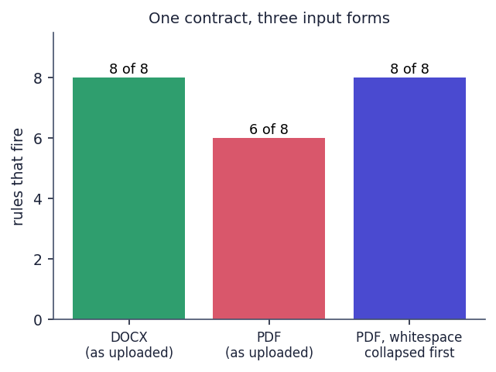
Fig. 2: The same contract as DOCX, as PDF, and as PDF with whitespace collapsed before matching

3.4 Limits applied before calling the model
To bound cost and prompt size, the embedding call receives the first 8,000 characters of a clause, the tie-break and explanation prompts the first 1,500 characters, and the summary prompt the first 40 clauses with 400 characters each. A contract with more than 40 clauses is therefore summarised from its first 40 clauses only, although every clause is still classified and checked by the rules.

4 Algorithm Choice and Justification
Table 4: Algorithm choices
Decision | Chosen | Alternatives | Why
Clause type | Gemini embedding + nearest centroid of 20 CUAD categories [13] | TF-IDF [14] centroid 0.621, TF-IDF + logistic regression (scikit-learn [17]) 0.675, 1-NN 0.604, 5-NN 0.746, embedding + logistic regression 0.800 (all measured) | No training step and no extra service beyond the embedding call; 500 spans are enough to give 20 centroids; new categories need only examples
Predatory decision | Eight regular-expression rules | A classifier trained on labelled predatory clauses; an LLM verdict | No labelled Indian predatory-clause data exists; a rule is auditable, deterministic and free; the price is recall (section 6.6)
Combinations | Three fixed rule-id sets matched anywhere in the contract; NetworkX graph [16] | Neo4j knowledge graph with concepts and precedents (abstract) | A single-process, dependency-light build; three patterns need no query language; edges are derived, not stored
Wording | Gemini, one call per flag and one for the summary | Fixed templates | The reason must refer to the actual wording and the safer clause must keep its purpose, which a template cannot do
Complexity | Weighted sum of four lexical measures [15] | A model trained on human difficulty ratings | No ratings exist; the formula is transparent; weights are the author's and not validated
Storage | SQLite blobs + NumPy cosine | pgvector, a vector database | At 20 centroids and tens of clauses per contract a linear scan is immediate

The comparison on the held-out spans is an honest one. The shipped nearest-centroid classifier scores 0.792, while a logistic regression trained on the same embeddings scores 0.800. With 240 test items the binomial standard error of an accuracy near 0.80 is about 2.6 points, so the two are indistinguishable; the nearest-centroid method was kept because it needs no fitting and is easy to explain, not because it is more accurate. The embedding methods are clearly better than the TF-IDF baselines (0.117 above the best of them), and all are far above chance (0.05).
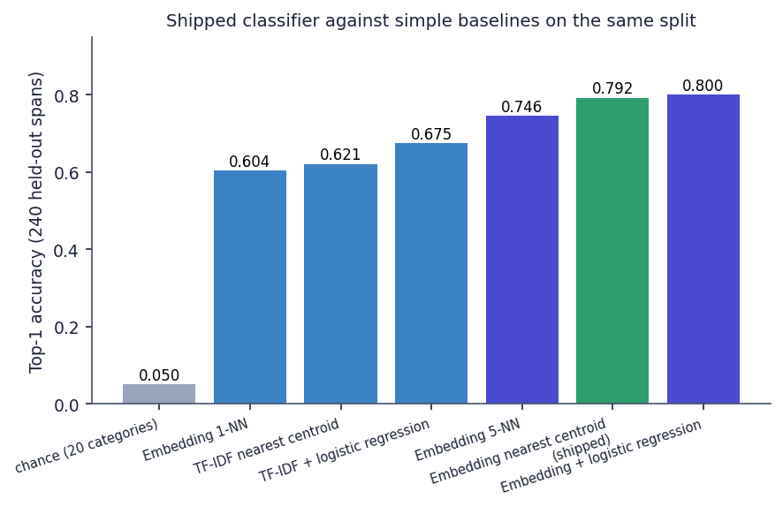
Fig. 3: Shipped classifier against simple baselines on the same 240 held-out spans
The rule engine was kept simple for a reason that is also its weakness. A regular expression never changes its answer, so a lawyer can read every rule; but it only recognises the vocabulary it was written for. The rules were written before the independent probe set existed and were not changed after it, so the probe scores in section 6.6 are an honest estimate of how the rules behave on wording they were not tuned for.

5 Mathematical Formulation
The formulas below are those implemented in the code; symbols are defined where they are used.

5.1 Clause classification
Let e(t) in R^3072 be the Gemini embedding of a text t. For each of the K = 20 categories, the centroid is the mean of the embeddings of its n = 25 training spans, c_k = (1 / n) Σ_(t in S_k) e(t), computed with the task type RETRIEVAL_DOCUMENT; a clause x is embedded with RETRIEVAL_QUERY. The similarity of the clause to category k is the cosine s_k = (e(x) · c_k) / ( ||e(x)|| ||c_k|| ). Sort the similarities so that s_(1) >= s_(2) >= s_(3) ... and let k_1, k_2, k_3 be the corresponding categories. The embedding label is k_1 with confidence s_(1).
Tie-break rule. If s_(1) - s_(2) < 0.03 and s_(1) < 0.60, Gemini is asked to choose one of {k_1, k_2, k_3}; if it answers with a category outside this set, the label is k_1 and the confidence s_(1); otherwise the label is the chosen category and the confidence is the value that Gemini returns. Confidence floor. If the final confidence is below 0.35 the label is replaced by "Other / Unclassified". The margin is the named constant TIE_BREAK_MARGIN = 0.03 in classification.py; 0.60 and 0.35 are literals in the same function.

5.2 Predatory-clause rules and combinations
Each rule j is a regular expression ρ_j, and the flag indicator for clause x is r_j(x) = 1 if ρ_j matches x (case-insensitively) and 0 otherwise. The flag set is F(x) = { j : r_j(x) = 1 }. A combination C is a fixed set of rule ids; with U the union of F(x) over all clauses x of the contract, C fires when C is a subset of U, and the clauses involved are all clauses carrying at least one rule of C. Edges are drawn between every pair of involved clauses. Because the test uses only the set U, it does not require the rules to occur in neighbouring clauses or to disadvantage the same party.

5.3 Complexity score
Let W be the number of words, S the number of sentences, Y the number of syllables (counted as groups of vowels aeiouy, minus a silent final e), L the number of hits of 34 legal-jargon terms (substring counts), X the number of cross-references ("Section 4.2", "Clause 9", "herein", "hereof" and similar) and n the number of clauses. The Flesch reading ease [15] is FRE = 206.835 - 1.015 (W / S) - 84.6 (Y / W), clipped to [0, 100]. The legalese density is D_L = 100 L / W and the average sentence length is a = W / S. Four difficulty values in [0, 100] are formed:
1. readability difficulty D_r = 100 - FRE;
2. jargon difficulty D_j = min(100, 8 D_L);
3. cross-reference difficulty D_x = min(100, 40 X / n);
4. sentence difficulty D_s = min(100, max(0, 3 (a - 15))).
The complexity score is Score = 0.35 D_r + 0.30 D_j + 0.20 D_x + 0.15 D_s, rounded to one decimal, and the grade is A for Score < 20, B for < 40, C for < 60, D for < 80 and F otherwise. The weights and cut-offs were chosen by the author and have not been validated against human ratings.

5.4 Evaluation measures
For the rules, true positives, false positives and false negatives are counted over (clause, rule) pairs: TP = Σ |F(x) ∩ G(x)|, FP = Σ |F(x) \ G(x)|, FN = Σ |G(x) \ F(x)|, where G(x) is the set of expected rule ids. Precision P = TP / (TP + FP), recall R = TP / (TP + FN) and F1 = 2 P R / (P + R); these are micro-averaged over rules. For classification, top-k accuracy is the share of held-out spans whose true category is among the k most similar centroids, and the per-category recall is the share of that category's 12 spans that receive its label. The standard error of an accuracy p measured on N items is √( p (1 - p) / N ), which is about 0.026 for p = 0.79 and N = 240.

6 Model Construction, Thresholds and Measured Results
No model is trained in this project. The embedding model and the text model are remote Gemini services that were used as they are. The only fitted quantities are the 20 centroids, which are means of 25 embeddings each and are built once and cached in data/cuad_centroids.npz, and the three thresholds (0.03, 0.60, 0.35) and the weights of the complexity score, which are constants chosen by the author. This section describes how these were evaluated.
Table 5: Configuration of the analysis pipeline
Item | Value
Embedding model | gemini-embedding-001, 3,072 values per vector; RETRIEVAL_DOCUMENT for the training spans, RETRIEVAL_QUERY for clauses
Centroids | 20 categories x 25 spans, mean of float32 vectors; cached after the first build
Tie-break | margin < 0.03 and top-1 similarity < 0.60; Gemini chooses among the top 3
Confidence floor | below 0.35 gives "Other / Unclassified"
Text model | default gemini-flash-latest; the measured runs used gemini-3.1-flash-lite because the default exceeded the free-tier limit of 20 requests per day
Retries | 3 attempts per text call, sleeping 1.5 s, 3 s and 4.5 s
Randomness | None in the product; the data split uses seed 42

6.1 Experimental protocol
1. scripts/exp_embed_cache.py embeds the 500 training spans and the 240 held-out spans with the same Gemini calls the product makes and caches the 740 vectors (about 7 minutes).
2. scripts/exp_classification.py runs the unmodified ml/eval.py with its embedding call answered from the cache, so experiments/eval/metrics.json holds exactly what the shipped evaluation code computes. It then adds checks the shipped evaluation does not make.
3. scripts/exp_rules_corpus.py scores the rules on the shipped 40-clause set, on a second independent set, on CUAD spans, and runs the non-API pipeline over all 510 CUAD contracts.
4. scripts/exp_format_parity.py compares the flags for a DOCX and a PDF of the same text.

6.2 Classification on 240 held-out CUAD spans
The shipped evaluation code reports top-1 accuracy 0.792 and top-3 accuracy 0.979 over 240 spans and 20 categories (chance is 0.05); top-5 is 0.983. After removing the 4 spans that duplicate a training text, top-1 is 0.797. Rebuilding the centroids without any training span from the same contract as the test span (192 of the 240 items had such a span) gives 0.800, so the contract overlap did not inflate the score. Recall is highest for Governing Law, Ip Ownership Assignment and Renewal Term (1.00 each) and lowest for Non-Compete and Cap On Liability (0.50 each), No-Solicit Of Customers (0.58) and Exclusivity, Liquidated Damages and Uncapped Liability (0.67 each). The largest confusions are Uncapped Liability predicted as Cap On Liability (4), Non-Compete as No-Solicit Of Customers (4) and the two no-solicit categories with each other (3 and 3): neighbouring legal concepts with similar vocabulary.
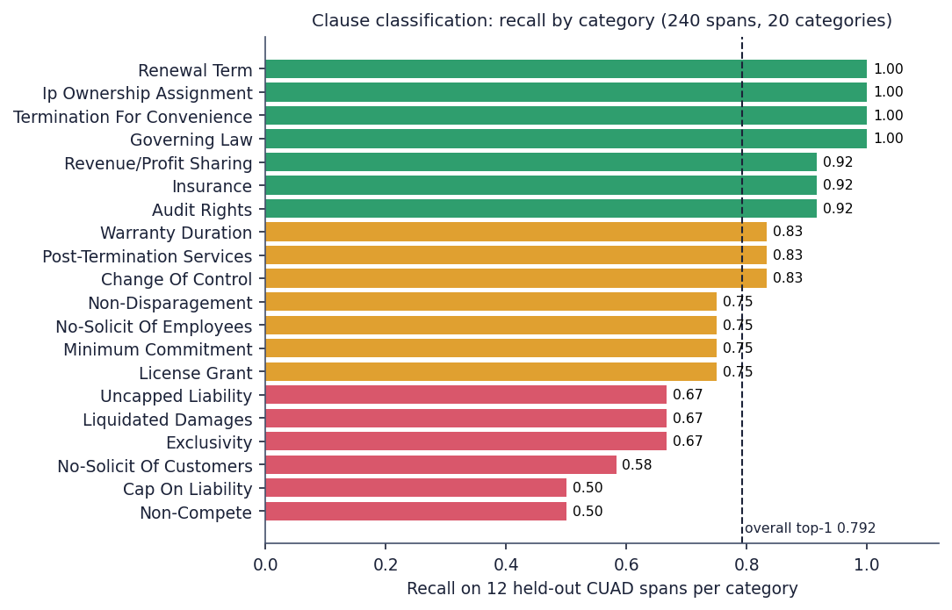
Fig. 4: Recall of the classifier in each of the 20 categories (12 held-out spans each)
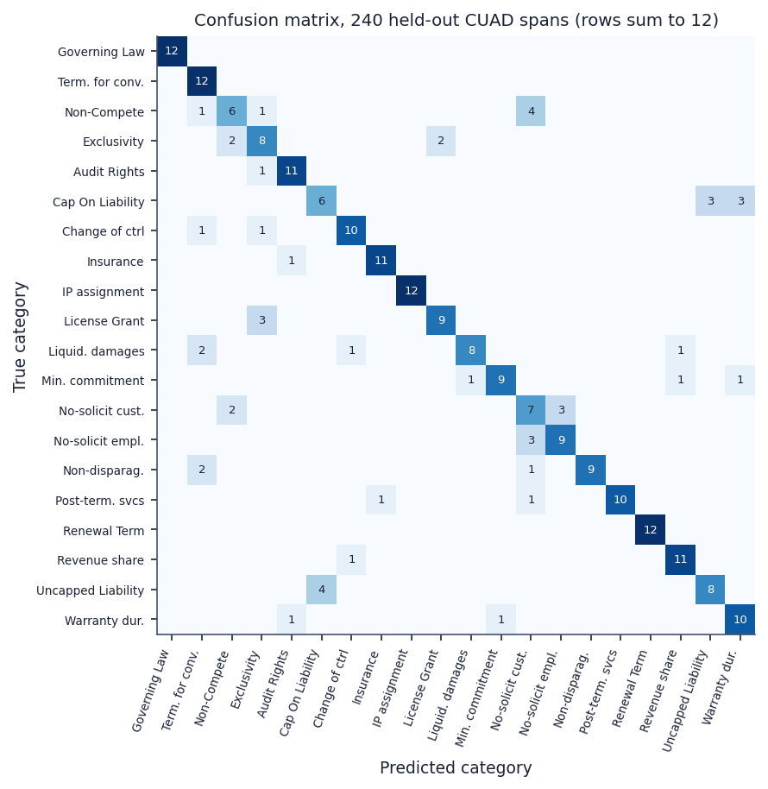
Fig. 5: Confusion matrix on the 240 held-out spans

6.3 Two thresholds that never act
On the 240 spans the best cosine similarity ranges from 0.657 to 0.849 (median 0.767). The margin test alone would pass for 152 spans (the median margin between the best two categories is 0.023), but the tie-break also requires the best similarity to be below 0.60, and no span is below 0.657; and the floor of 0.35 is never reached. The same holds in the three real uploads: all 30 clauses carry the method embedding and confidences between 0.72 and 0.83. With this embedding model the two branches are dead code, and every clause is forced into one of the 20 labels, including boilerplate that belongs to none of them. The constants were evidently tuned for an embedding model with a different similarity scale. Accuracy by band confirms that confidence is a weak signal: 0.600 for the five spans between 0.65 and 0.70 and 0.796 for the 235 above 0.70.
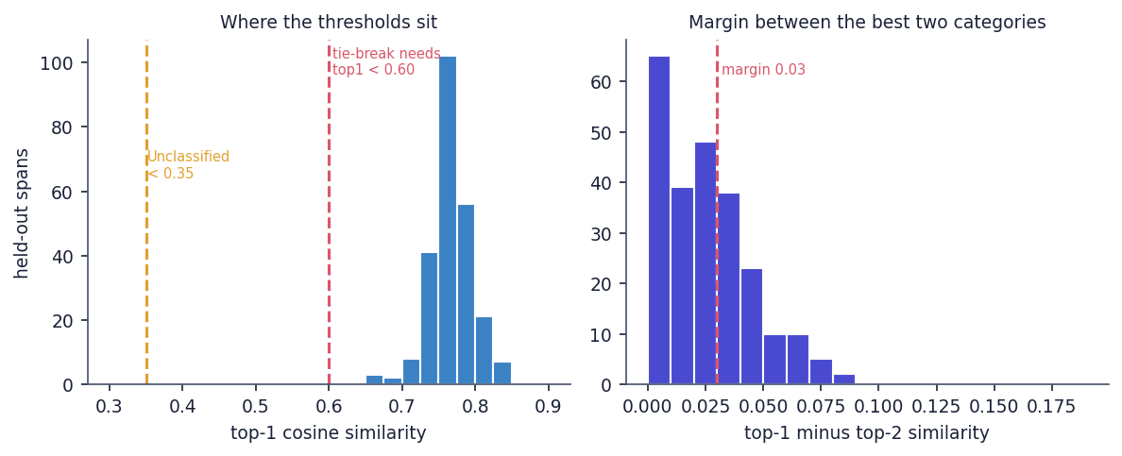
Fig. 6: Where the two thresholds sit relative to the measured similarities
A further observation concerns whole clauses. In a manual reading of the 19 clauses of the two invented contracts, 9 received a plausible label (5 of 11 and 4 of 8), noticeably below the 79 % obtained on short spans. For example, the fees clause of the fair contract was labelled Liquidated Damages and its confidentiality clause Post-Termination Services. This is a small, informal check, but it agrees with the difference in text length between the test spans and real clauses.

6.4 Predatory-clause rules
Table 6: Rule scores on the two test sets
Test set | Items | TP | FP | FN | Precision | Recall | F1
Shipped set (written with the rules) | 40 clauses | 32 | 0 | 2 | 1.000 | 0.941 | 0.970
Independent probe set | 24 + 16 clauses | 11 | 3 | 13 | 0.786 | 0.458 | 0.579

The shipped set reproduces the published figures (precision 1.00, recall 0.94, F1 0.97), but it was written by the author of the rules, so it measures whether the rules find the wording they were written for. On 40 clauses phrased independently, 24 predatory paraphrases and 16 benign look-alikes, the same rules give precision 0.79 and recall 0.46. Thirteen paraphrases were missed (for example "agrees not to accept any engagement", "cannot be returned for any reason", "liability ... shall be unlimited", "sole arbitrator appointed by the Company") and three benign clauses were flagged (a capped liquidated-damages clause, a conflict-of-interest restriction and mutual liability for gross negligence). Per-rule recall on the probe set is 0.67 for auto_renewal, ip_overreach and unilateral_termination and 0.33 for the other five rules.
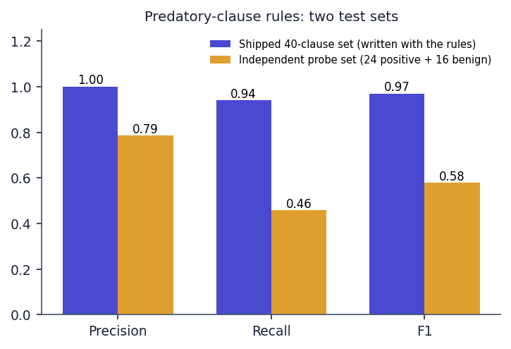
Fig. 7: Rule precision, recall and F1 on the shipped set and on the independent probe set
A second view comes from CUAD. CUAD's categories are not the same concept as "predatory", so the figures below are a proxy and not a recall: they give the share of CUAD spans of the closest category on which a rule fires. The rule fires on 56.2 % of Liquidated Damages spans, 33.2 % of Renewal Term, 13.0 % of Termination For Convenience, 8.2 % of Non-Compete, and on none of the 167 Uncapped Liability or 317 Ip Ownership Assignment spans, because United States drafting uses different phrases. On 5,032 spans of 11 unrelated categories a rule fires on 37 (0.74 %).
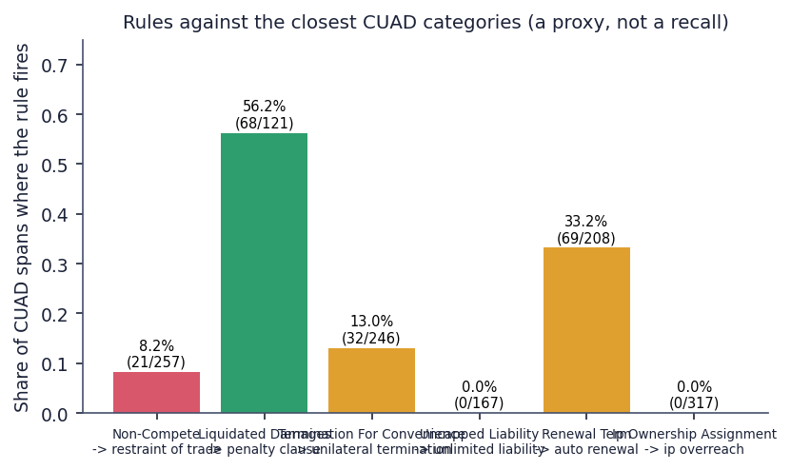
Fig. 8: Share of CUAD spans of the closest category on which each rule fires

6.5 Complexity score over the CUAD corpus
Over the 510 CUAD contracts the score has minimum 6.9, median 45.5, mean 45.8 and maximum 85.5 (standard deviation 12.3); the grades are A 4, B 169, C 268, D 68 and F 1. The score correlates only weakly with contract length (r = 0.297). The measure is lexical: the invented one-sided freelance contract, written in plain words, received grade B (23.3), and the fair contract grade A (13.7). The grade measures how hard a contract is to read, not how fair it is, and the interface labels it accordingly.
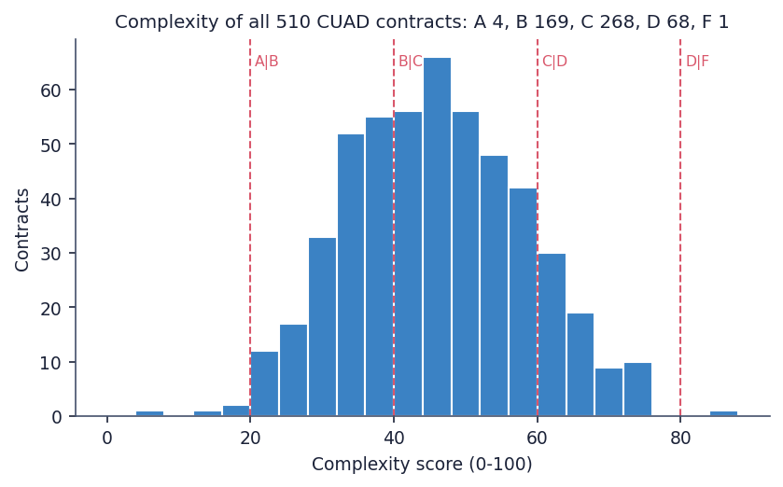
Fig. 9: Complexity scores of the 510 CUAD contracts

6.6 Run time
The non-API part of the pipeline (segmentation, rules, combinations and complexity) processed the 510 contracts in 28.49 s, 56 ms per contract. An upload is dominated by Gemini: the measured uploads took 15.5 s (8 clauses, no flag), 54.6 s (11 clauses, 1 flag) and 113.6 s (11 clauses, 8 flags), that is, about 12 seconds per text call. The API endpoints that do not call Gemini answered in 2 to 15 ms, with the bcrypt endpoints near 255 ms.

7 Base Paper Analysis
Base paper. F. Almutairy, S. Almutairi, M. Abdullah, and S. Salman, "SmartLaw Advisor: AI-powered legal consultation and contract analysis for Saudi Arabia," IEEE Access, vol. 14, pp. 32638 ff., 2026, doi: 10.1109/ACCESS.2026.3665420.
Problem and scope. Almutairy et al. start from the complexity of local laws and the scarcity of affordable legal support in Saudi Arabia, and from the absence of Arabic digital assistants aligned with Saudi legislation. They propose a virtual legal advisory platform with two functions: a legal chatbot that answers questions from a Saudi legal corpus, and a contract analysis system that extracts and classifies clauses of Arabic documents and checks them against national law. The paper was received on 24 December 2025 and published on 17 February 2026.
Retrieval pipeline. The chatbot uses retrieval-augmented generation. Legal documents are cut into coherent chunks by a semantic chunking step with a window of at most 1,024 tokens, embedded with GATE-AraBERT-v1 (an Arabic embedding model fine-tuned on legal terms), and indexed in the Chroma vector database (the paper also mentions a FAISS index of about 18,400 vectors and 152 MB). A query is embedded by the same model, the nearest chunks are retrieved (the paper states that the retriever returns a small number of candidates, k = 1), re-ranked by a cross-encoder (ARA-Reranker-V1), compressed to the essential passage and passed to Gemini 1.5 Flash. The generation settings are a temperature of 0.2, a maximum of 1,024 tokens, top-p 0.95 and top-k 40, so that the answer is nearly deterministic and tied to the supplied context.
Contract analysis. A user uploads a PDF, which is read by an OCR step that uses the multimodal ability of Gemini and is validated for errors in dates, figures and clause numbers. Each contract is compared with a checklist of essential clauses (payment terms, governing law, dispute resolution, termination, liability allocation, confidentiality and force majeure) that Saudi legal practitioners validated, and every clause is analysed by the language model for prohibited terms, ambiguous obligations and legally incomplete formulations. The paper describes the combination as hybrid rule-based and LLM-guided. The output is structured JSON with recommendations in Arabic, and a further step lists contradictory clause pairs.
Data and experiments. The evaluation set has 150 legal questions over ten legal domains and 50 real contract drafts; the authors justify the small size by the lack of public machine-readable Saudi legal data and by privacy rules, and note that the sets were built under expert supervision. All experiments ran in a cloud environment (Intel Xeon Platinum 8272CL, 32 GB, Ubuntu 20.04, API round-trip of 280 to 350 ms) and timings were averaged over three runs.
Reported results. Without retrieval, Gemini 1.5 Flash answered 148 of 150 questions correctly (98.67%) with an average response time of 1.63 s, ahead of GPT-3.5 (98.00%, 147 correct), GPT-4 (97.33%, 146, 2.56 s) and ALLaM (96.00%, 144, 4.51 s). With RAG the average similarity to the reference answer was 96.57% for Gemini at 143.52 s per query, which the authors explain as the cost of a full evaluation pipeline without caching, not the latency of the deployed system. For contract analysis the paper reports no numeric score; it compares sample outputs. In the sample shown, Gemini returned seven flagged clauses, six of which were judged accurate and the first erroneous, ALLaM nine (the first incorrect, with repetition), Command A five (the first incorrect) and GPT-4 six (the first wrong, and one clause that merged three issues).
Failure cases and limitations stated by the authors. Three kinds of error are described: incomplete retrieval when a relevant clause spans several chunks, misclassification of multi-purpose clauses that cover payment, liability and confidentiality together (the model assigns only one category), and, in a few answers, a statutory citation that was not in the retrieved context. They also note that performance on very ambiguous texts may vary, that a limited legal database restricts adaptation to changing regulation, that language models carry bias, and that legal data are unstructured and must be cleaned.
What ClauseGuard adopts and what it changes. ClauseGuard keeps the jurisdiction-aware, language-model-based design: contract text is turned into clauses, clause-level analysis uses a hosted Gemini model, and the result is written in plain language. It changes the following: the jurisdiction (Indian law, English text), the detection method (curated rules tied to statutes instead of a checklist and free-form LLM judgement), the unit of risk (combinations of clauses, which the base paper's own failure analysis does not address), the addition of a complexity grade, and the evaluation (clause classification and predatory detection scored separately on stated data). It drops the pieces it did not build: the legal-corpus retrieval with re-ranking, OCR and the chatbot.
Table 7: Base paper compared with ClauseGuard
Aspect | Base paper [1] | ClauseGuard
Jurisdiction and language | Saudi law, Arabic | Indian contract law, English
Language model | Gemini 1.5 Flash | Gemini (embeddings; text model gemini-flash-latest by default, gemini-3.1-flash-lite in the measured run)
Retrieval | Semantic chunks, GATE-AraBERT-v1, Chroma, cross-encoder re-ranking | No legal-corpus retrieval; nearest centroid over 20 CUAD categories (NumPy cosine, SQLite vectors)
Contract analysis | Checklist of essential clauses plus clause-level LLM analysis; contradiction pairs | Eight statute-tagged regex rules, three clause combinations, LLM explanation and safer wording
Complexity measure | None | Flesch, legalese density, cross-references, sentence length, A-F grade
Input | PDF through an OCR step | PDF (text layer) and DOCX; no OCR
Data | 150 questions, 50 contract drafts (Arabic) | CUAD for classification (240 held-out spans), 40 curated clauses and 40 probe clauses for rules, 510 CUAD contracts for scale
Evidence of contract analysis | Qualitative comparison of sample outputs | Measured: precision 1.000 / recall 0.941 (authored set), 0.786 / 0.458 (probe set); top-1 0.792 (classification)
Comparability | Different language, law, task and data | No numeric head-to-head is claimed

8 Novelty Compared with the Base Paper
The base paper [1] (Almutairy et al., IEEE Access, 2026) is a Saudi-law system with two parts: a retrieval-augmented legal chatbot over an Arabic corpus and a contract-analysis module that checks Arabic contracts against a checklist of essential clauses with an LLM. ClauseGuard keeps the idea of a jurisdiction-aware, Gemini-based contract reader and changes the target (English-language Indian contracts), the analysis (clause-level rules and clause combinations, a complexity grade) and the way the system is evaluated. The table lists the differences; none of them is claimed as new to the field, and the two systems are not compared numerically because their tasks, data and metrics differ.
Table 8: What differs from the base paper
Element | Base paper [1] | ClauseGuard (this project)
Jurisdiction and language | Saudi law, Arabic contracts and questions | Indian contract law (Contract Act 1872 ss. 27, 73, 74; Arbitration and Conciliation Act 1996; Consumer Protection Act 2019; Copyright Act 1957), English contracts
Retrieval and corpus | Custom Arabic legal corpus, GATE-AraBERT embeddings, Chroma and a FAISS index of about 18,400 vectors, cross-encoder re-ranking | No legal corpus: 500 CUAD clause spans give 20 category centroids; Gemini embeddings (3,072-d) compared by cosine similarity in NumPy
Contract analysis | Checklist of essential clauses plus LLM-assisted semantic check of each clause | 8 deterministic regex rules tied to Indian statutes, 3 clause-combination patterns, a complexity grade A-F; the LLM only writes the explanation and safer wording
Output | Chatbot answers and a clause-by-clause assessment of the draft | Per-contract grade, flagged clauses with reason, quoted provision and safer wording, clause graph, plain summary and obligations
Evaluation | 150 legal questions (accuracy 98.67 % for Gemini 1.5 Flash); contract analysis judged qualitatively on sample outputs for 50 contract drafts | Classification (top-1 79.2 %, top-3 97.9 % on 240 CUAD spans) and predatory-clause rules scored separately; an independent probe set (precision 0.79, recall 0.46); a 510-contract run; 68 automated tests
Delivery | Platform with chatbot and analysis modules | Web application with accounts, upload, report, clause pages and graph, evaluation screen
Evidence of limits | Failure cases noted: retrieval across chunk boundaries and clause misclassification | Measured limits: paraphrases missed by the rules, PDF line breaks losing 2 of 8 rules, thresholds that never fire, forced labels, 113.6 s upload

9 Key Contributions
1. An end-to-end contract reviewer for Indian agreements. One application, ClauseGuard, that parses PDF and DOCX files, segments them into clauses with page numbers, classifies each clause, flags predatory terms, finds risky combinations, grades complexity and explains each flag, with 9 API endpoints, 4 database tables and 7 screens. It adopts the jurisdiction-aware, language-model-based design of the base paper [1] for Indian contracts.
2. An Indian-law rule set with explanations. Eight regular-expression rules, each tied to a named statute [20]-[23], and for every flag a reason, the quoted provision and a safer wording written by the language model from the rule's stated legal basis. On the 40-clause test set written with the rules they reach precision 1.000 and recall 0.941; on an independent probe set of 40 clauses they reach precision 0.786 and recall 0.458, which is the more honest figure.
3. Clause-combination logic. Three combinations of rule identifiers (unilateral termination with no refund and penalty; restraint of trade with unlimited liability; automatic renewal with unilateral termination) are reported when all their rules occur anywhere in a contract. On the 510 CUAD contracts 11 show a combination; the invented one-sided contract shows all three.
4. A complexity grade. A weighted score from the Flesch reading ease [15], legal-jargon density, cross-reference count and sentence length, graded A to F. Over the 510 CUAD contracts the grades are A 4, B 169, C 268, D 68 and F 1. The measure is lexical: the invented one-sided contract scored B and the fair one A.
5. Separate evaluation of classification and predatory detection. Clause classification reaches top-1 accuracy 0.792 and top-3 accuracy 0.979 on 240 held-out CUAD spans in 20 categories, against 0.675 for a TF-IDF [14] plus logistic-regression baseline; predatory detection is scored on its own test sets. The two scores are never merged.
6. Measured findings about the build itself. Parity between DOCX and PDF input (8 of 8 rules against 6 of 8 on identical text), thresholds that never act (the tie-break and the Unclassified floor), a split of the evaluation data that is not contract-disjoint, a 56 ms per contract processing time for the non-API pipeline, and upload times of 15.5 s to 113.6 s. These are reported rather than hidden.
7. A tested and documented code base. A suite of 73 automated tests (68 pass, 5 expected failures that document known limits), API response times, and reproducible experiment scripts.
Contributions 1 to 4 are engineering contributions; contributions 5 and 6 are the evaluation contributions. Compared with the base paper [1], which works on Arabic text and Saudi law, retrieves from a legal corpus with a reranker and reports 98.67% accuracy on 150 legal questions, this project works on English contracts under Indian law, has no legal-corpus retrieval, adds combinations and a complexity grade, and reports its own metrics on its own data. The tasks and data differ, so no numeric head-to-head is claimed.

